**EF speed greater than 100**

Friday, November 8, 2019

9:55 AM

**Ticket 270687427**

**Reported issue:** ADIVB oppty 1-BTBE7E6 - unable to get Enhanced Features into this solution

**What to check:** run query to verify userid and record (oppty) name to pull in SE UI.

select * from amind.saved_progress where opty_id in ('1-BTBE7E6')



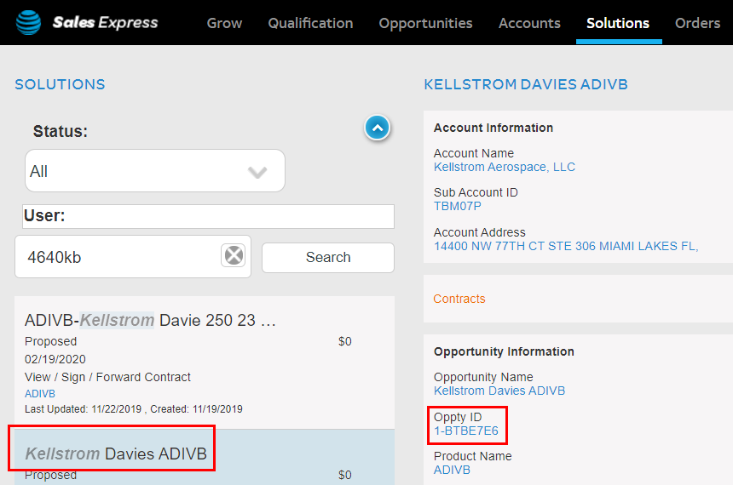

**Workaround (WA):** Please find below the steps for a WA, this will allow you to retain the ‘YES’ value for EF, and you will be able to proceed with EF in you order, but the WA needs to be implemented every time you land on the Voice page, so after selecting EF = ‘Yes’ once, I recommend you do not go back to Voice page again, or the earlier WA would be overwritten, and EF will get set back to NO, and the WA would have to be done all over again:

1. On the Config. Location Page itself, after selecting a Port Speed > 100mb,

open the file : js/managers/solutions/design-solution/**configure-voice-controller.js** in the console.

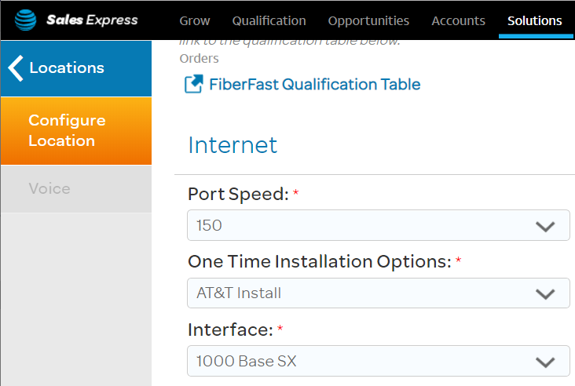

1. At line 65, add the below code, save the file, and click Save & Continue in UI.

**data.designSolution.steps[1].values[8].values[1].rules.assign.when[0].condition = "((not(inList(addIPTFsite, ['yes','Yes']))) and (not(inList(portSpeed, ['150Mbps', '250Mbps', '400Mbps', '500Mbps', '600Mbps','1000Mbps']))))";**

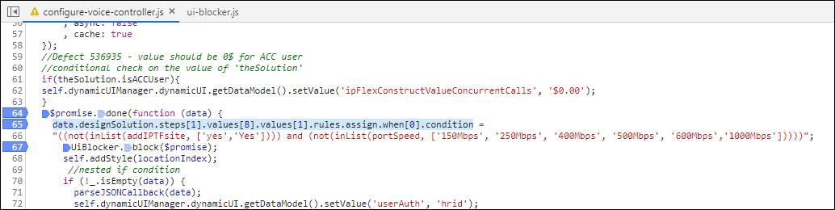

1. You’ll land on the ‘Voice’ page, with EF set to Yes. Toggle the EF value i.e. select ‘No’ once, then click on ‘Yes’ again, and then proceed with Save & Continue.

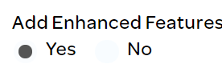

1. You’ll land on the ‘Pricing’ screen.

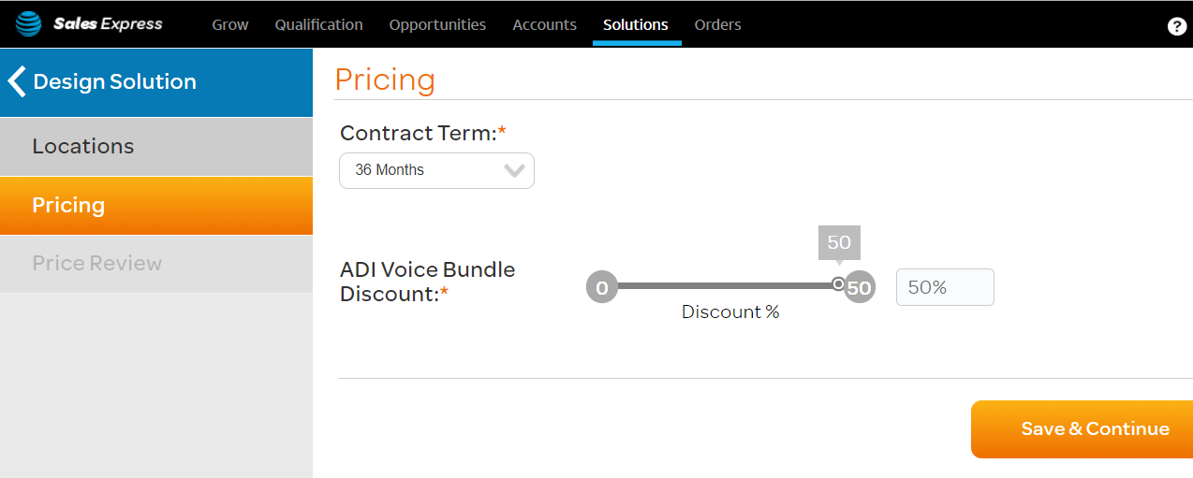

1. Here you can confirm that EF was indeed set to YES, by checking the following values in the console:

* **theSolution.sites[0].designSolution.voice.addEnhancedFeatures (must be “yes”)**
* **theSolution.sites[0].designSolution.voice.enhancedFeatures (must have value)**

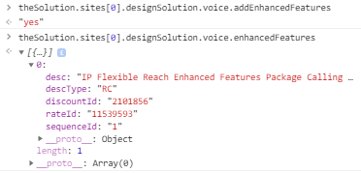

1. You can also confirm it in the Pricing Review screen:

